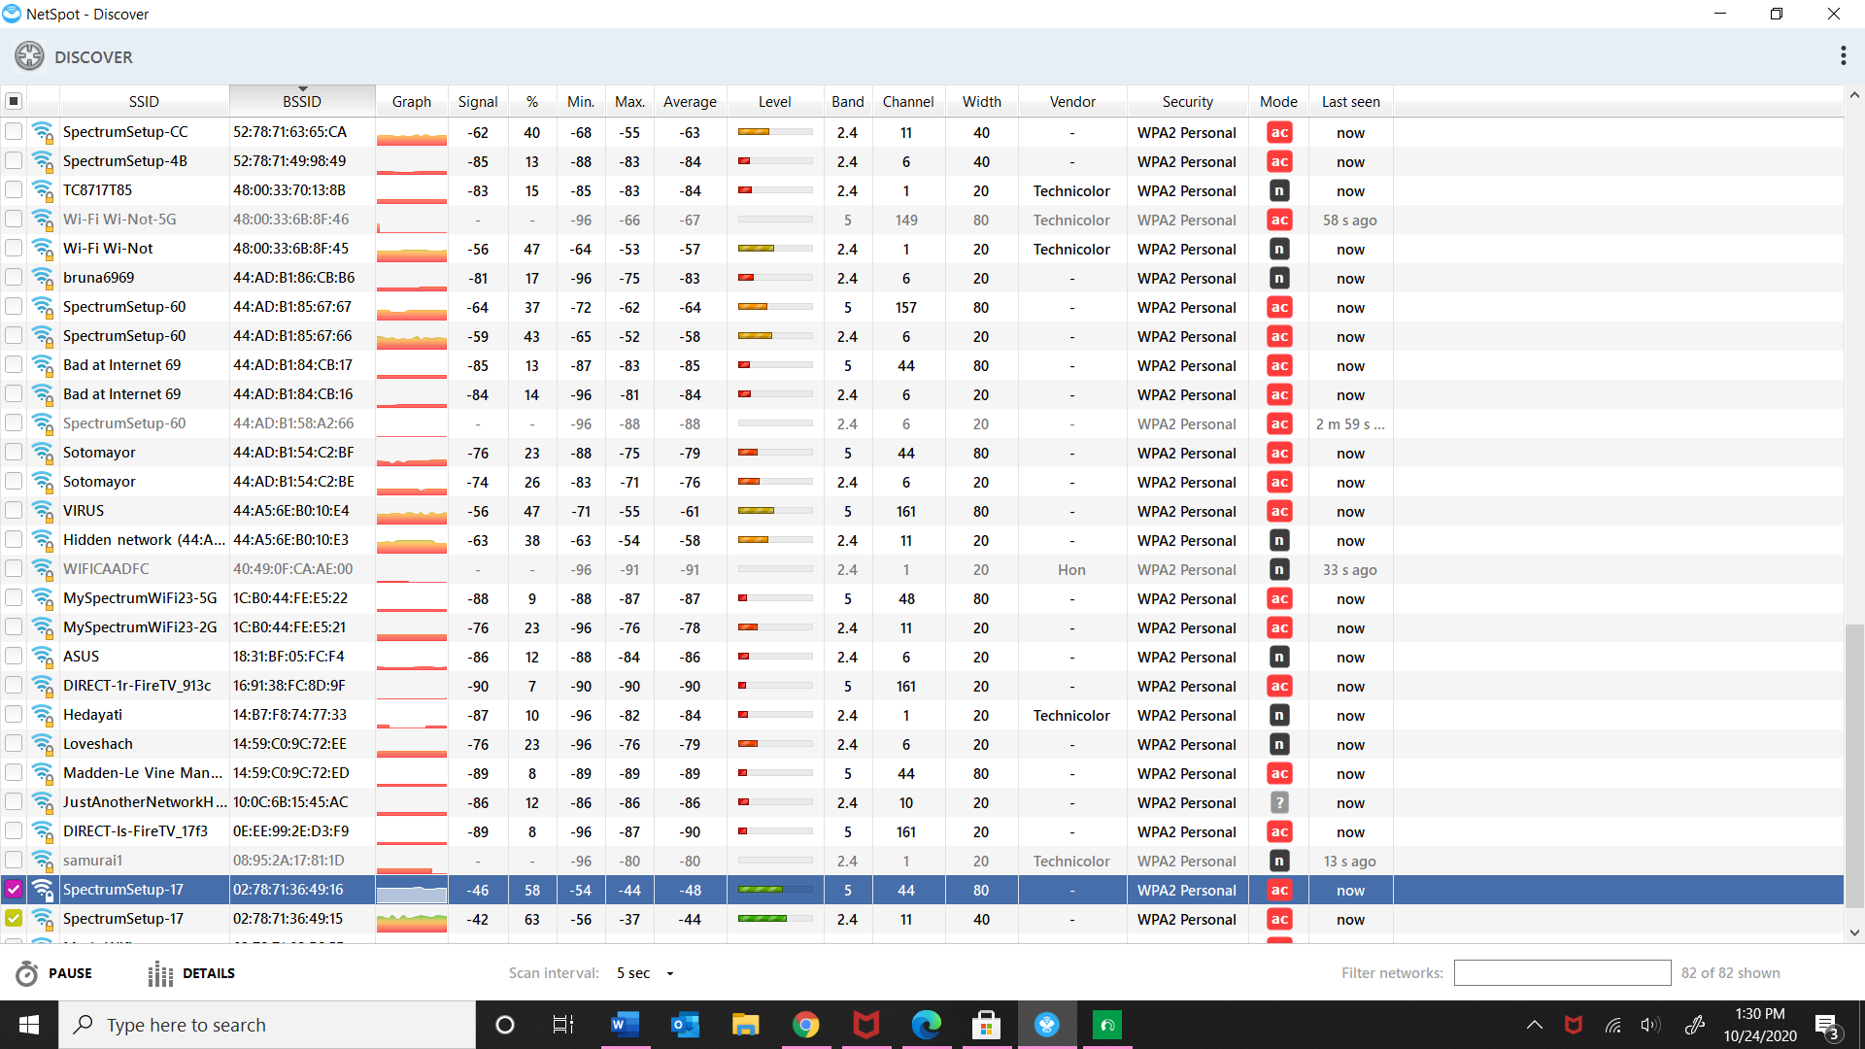

1. These are some of the available websites and the highlighted one is the Wi-Fi I am connected to.

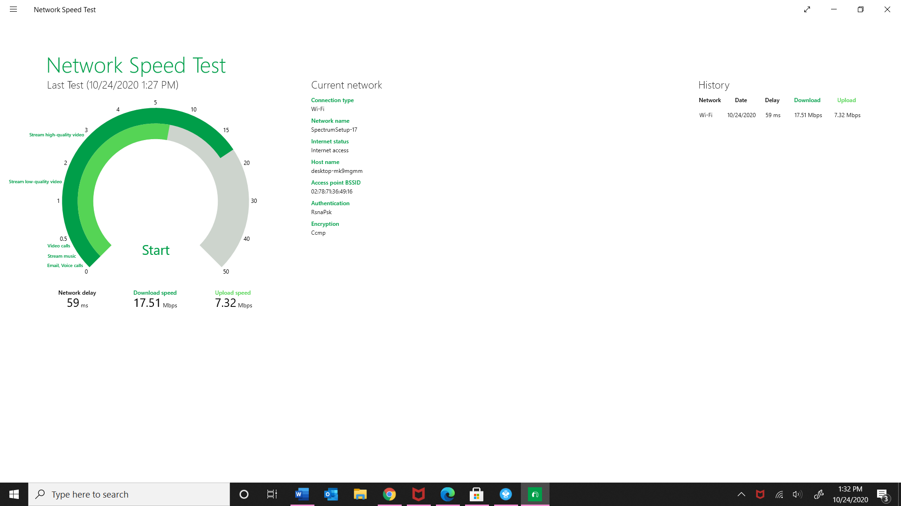

1. This is the maximum speed available speed. The different versions of 802.11 are: 2.4 and 5. The channel column on picture one shows all the available channels but the one I am connected to is channel 44.
2. The WPA2 are the most secure ones while the open Wi-Fi is not as secure.
3. Overall, it is secure (WPA2).